**Name: Sam Oun SONGHA**

**Class: WEP 2019**

**Quiz Database Auto Backup (Daily backup)**

1. **Step1**: Require XAMPP or WAMP (You can auto backup databases without start any service)
2. **Step2:** Create a file that has extension **.bat** (filename.bat) and write the command inside it by using any editor.
3. **Step3:** Make the configuration for database to set up user, password, directory and some files like zip & mysqldump

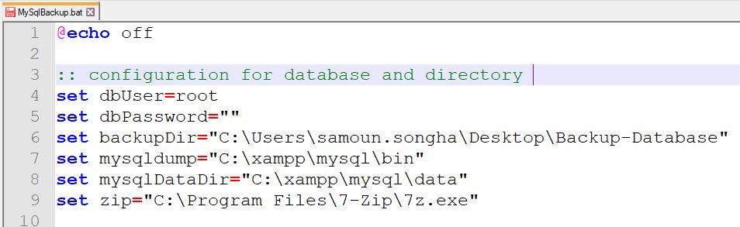

1. **set** dbUser : is a username for MySQL user
2. **set** dbPassword : the password for root user
3. **set** backupDir : set the directory that you want to put the database that backup already.
4. **set** mysqldump : we need to find the directory of **mysqldump** staying inside the xampp folder.
5. **set** mysqlDataDir : It’s the directory that has all databases.
6. **set** zip : We use this program for zip the database after backup.
7. **Step4:** These commands are written for get the current date in computer. And We have condition on Month, if the month equal to any number month, we will convert it to the letter of month: (example: 01 = Jan)

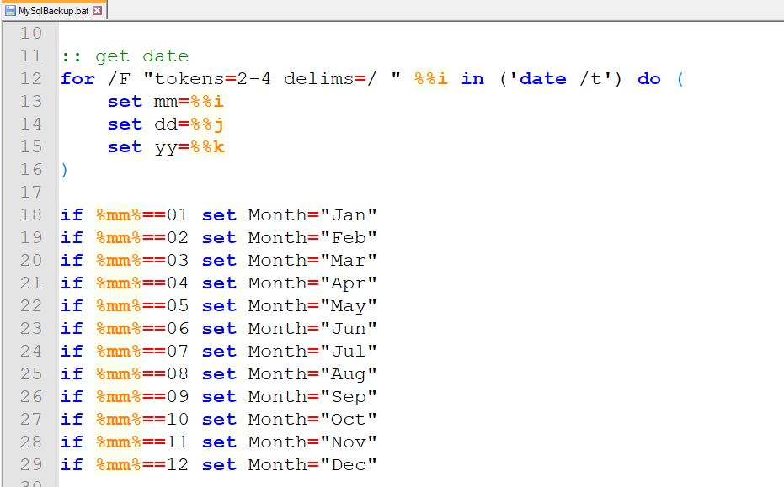

1. **Step5:** Set up the filename and directory name for store the backup files.

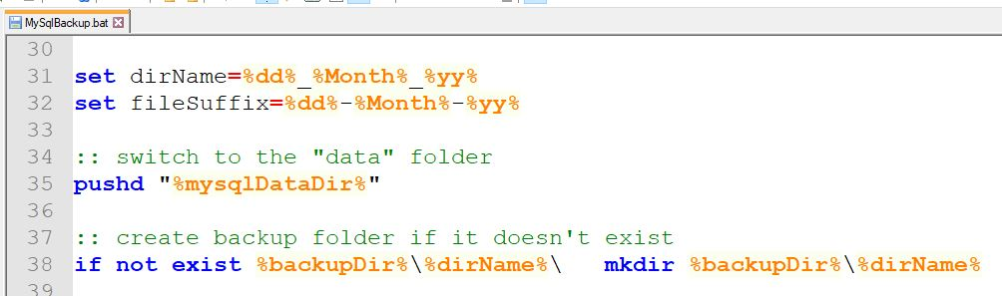

1. **set** dirName : it’s a directory name but we have the format **dd_mm_yy.**
2. **set** fileSuffix : It’s a file name, but it’s not the full name of file. It’s also format as date too.
3. **pushd:** we switch to the “data” folder
4. Create he backup folder if it doesn’t exist yet
5. **Step6:** Start backup the databases

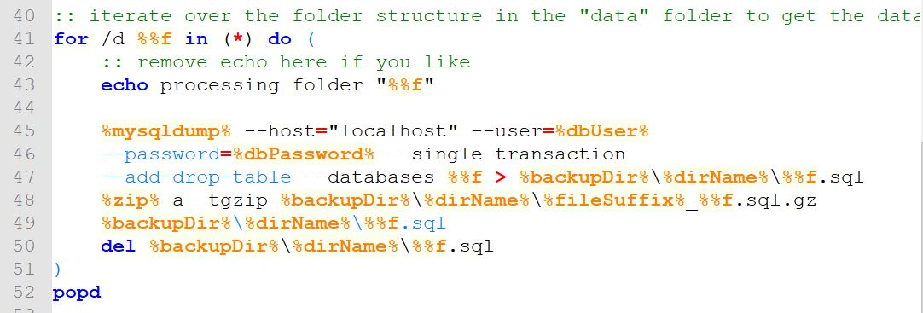

* Let see this: before it can backup, it iterates over the folder structure in the “data” folder to get the database
* **echo** processing folder “%%f” : It’s just use for check the file name from the database, but you can delete it if you want.
* **%mysqldump%** : So we start using this command for connect to user, password, hostname, directory name and set the filename. **(You need to write the following command above)** .
* **del** **%backupDir%\%dirName%\%%f.sql :** this statement is used for drop the database backup file which has the same name in the same date. But it will not delete if we it auto backup database at difference date. It will create new directory for store them.

**Note:** We see that, this bat file run only one time. You can set it on your own personal computer. So let do this:

1. Click on **Windows Key** and search for **task scheduler** which is a build in windows application.
2. 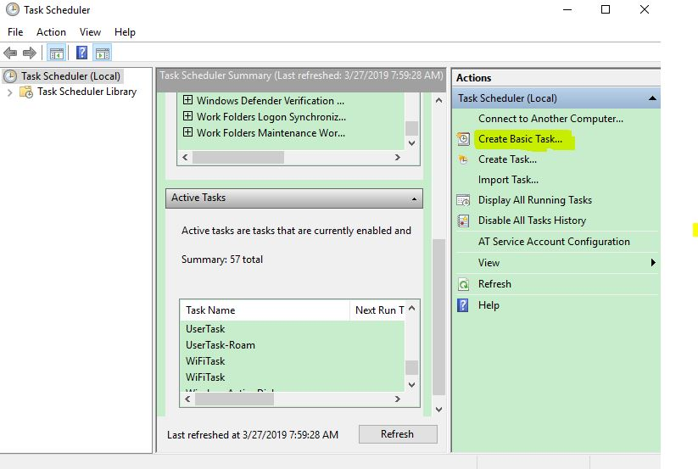**Run** the **task scheduler** application and click on **Create Basic Task…** at the right side.
3. Set the name for this task and description

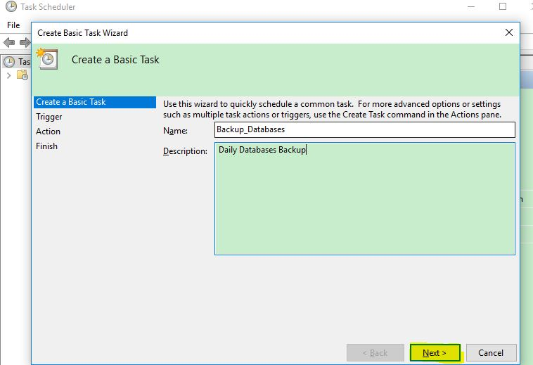

1. 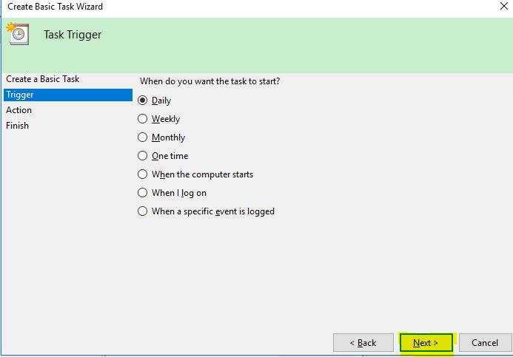On trigger: **you need to select on Daily** then click NEXT.
2. You need to set the time for backup on each day. And sync it with time zone.

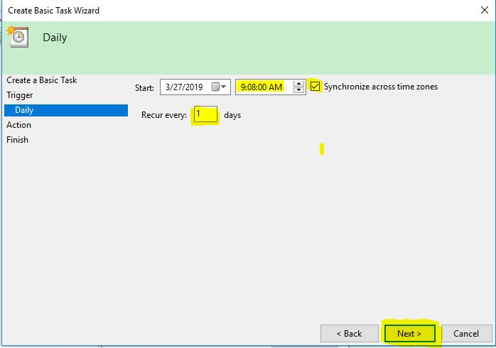

1. On Action select on **Start a program** and then click NEXT
2. You need to browse to the **.bat** file that you located in the computer. Then click NEXT.
3. This is a sum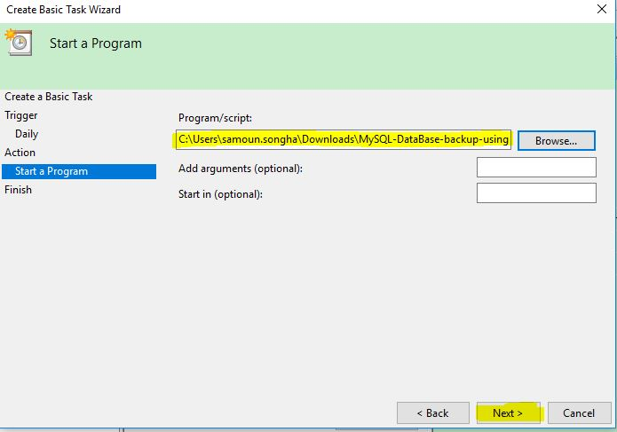mary for this task and click finish.

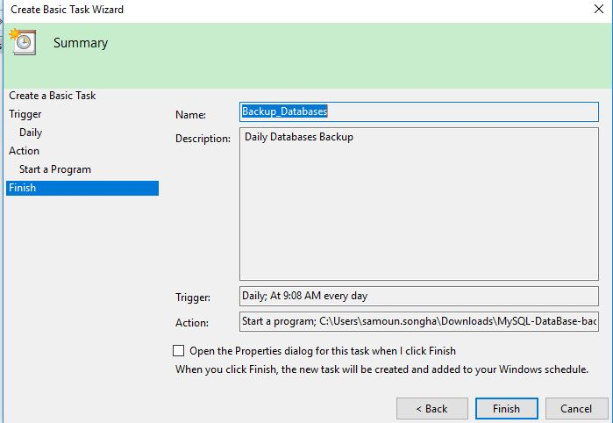

**Everything is done.** So here is the result that automatic backup on my computer:

Note: You need to change the directory of Data directory for Store database, and .bat file (in the task scheduler), if you want to test it.

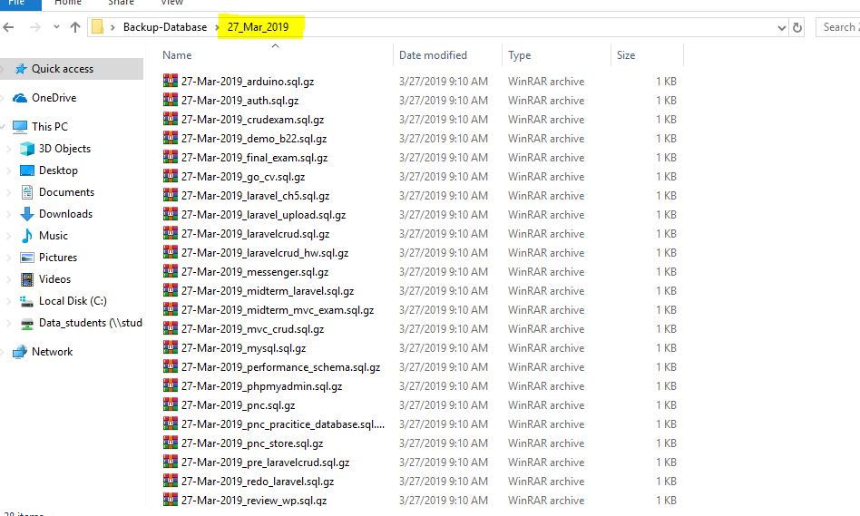**Thank you!**